

**WIF2003**

**WEB PROGRAMMING**

**PHASE 1 REPORT**

**LECTURER: DR. CHIAM YIN KIA**

|  |  |  |
| --- | --- | --- |
| **No.** | **NAMA** | **MATRIC NUMBER** |
| 1. | Arif Faisal Bin Ahmad Jais | WIF160003 |
| 2. | Ummu Atikah Binti Abdullah Sani | WIF160068 |
| 3. | Muhammad Irfan bin Ahmad | WIF160037 |
| 4. | Muhammad Faiz bin Hasnul | WIF160031 |

**Company details**

**Company name:** DEPTSCAPE

**Logo:**



**Guildlines**

1. index page

Our index page have a few button that user can interact with it. We have login, news and about button. Every button will go to other page.

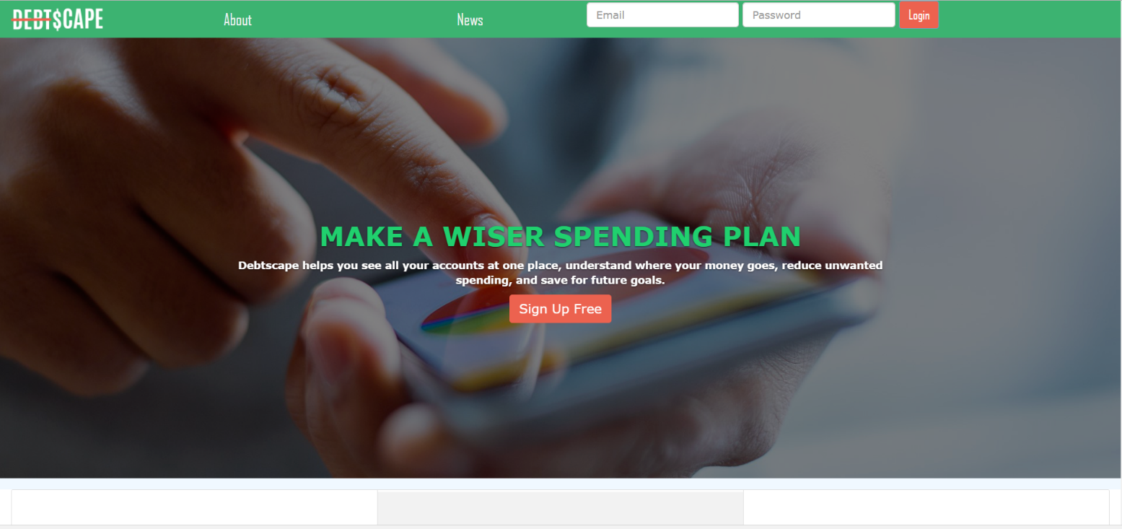

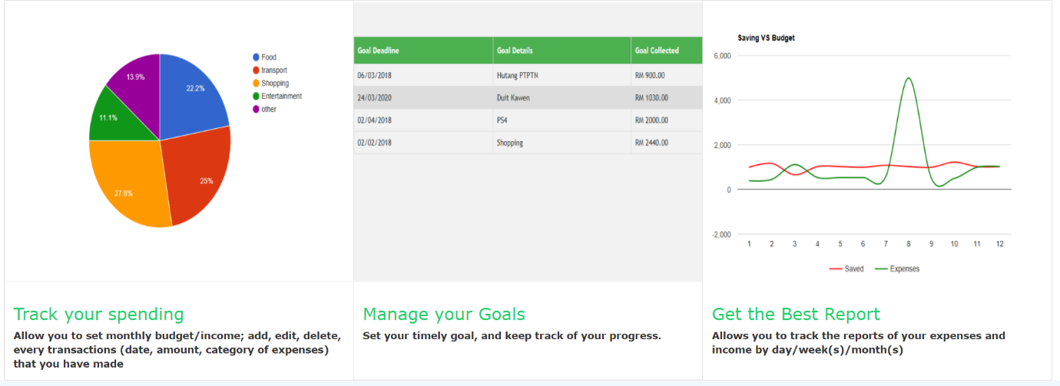



1. News page

News page will show the current information and famous topic that people talk about.





1. About us

This page is tell user our details.

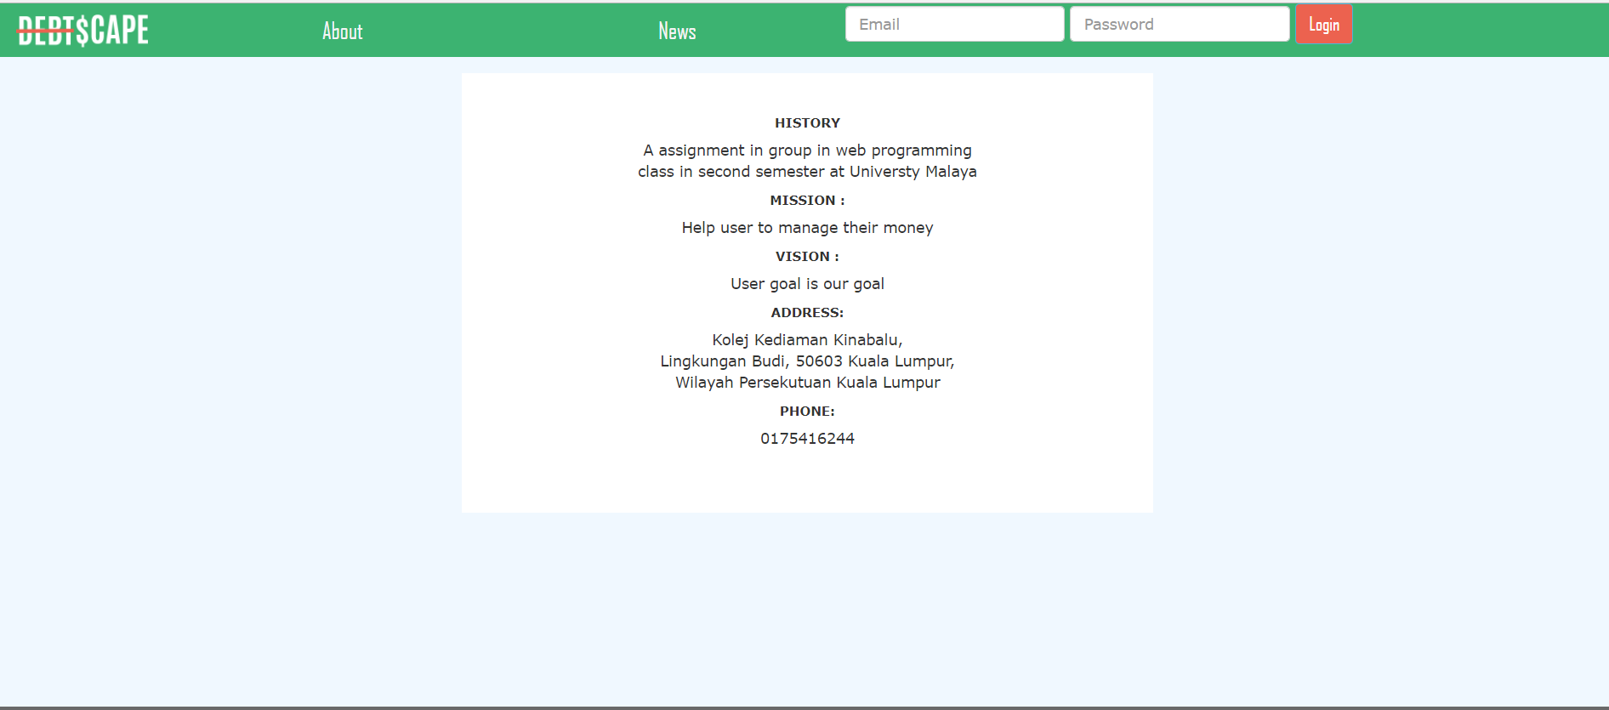

1. Login

This button is used by user that already have created an account can use advance features of the website.

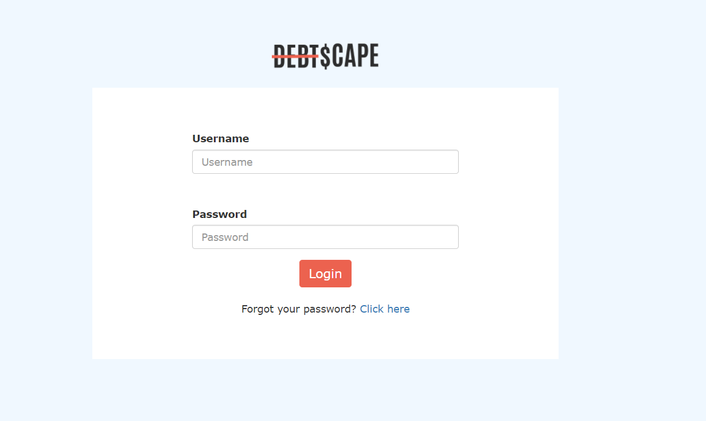

1. Sign up page

This page is used by the user that do not have an account. User need to insert few of their detail to make an account.

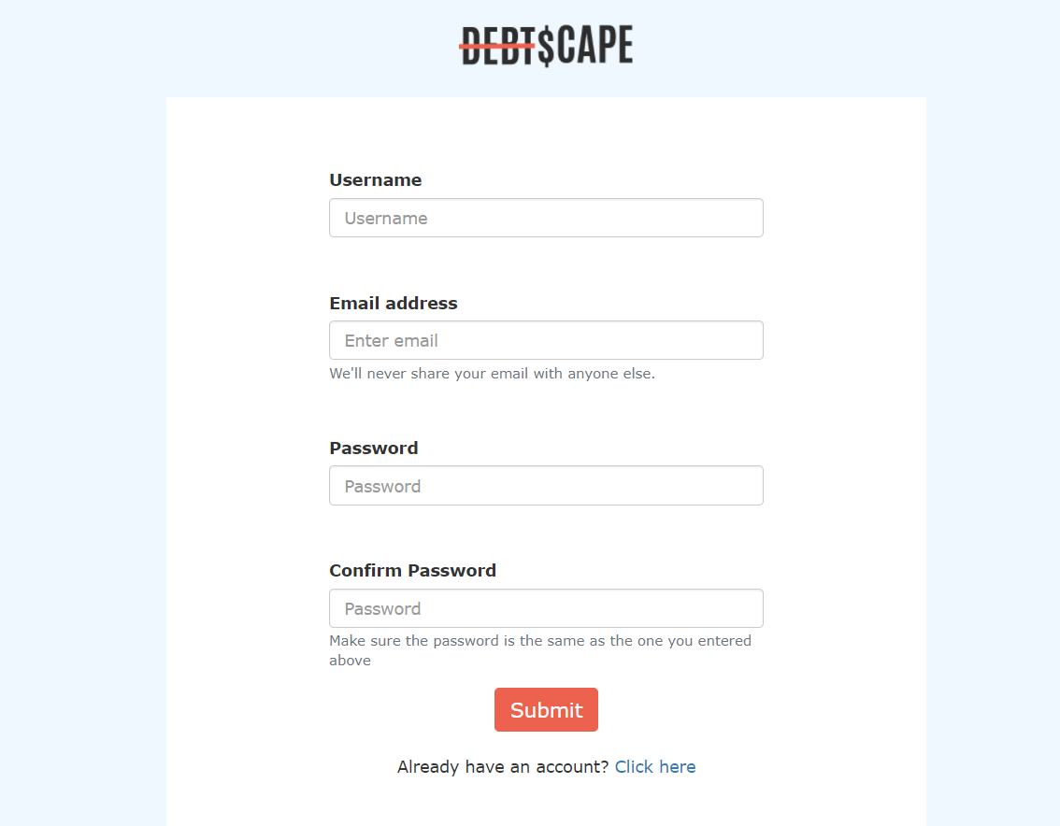

1. Report page

This page is used to track the user Saving and expenses. User can see trend of their saving and expenses that showed in the graph.

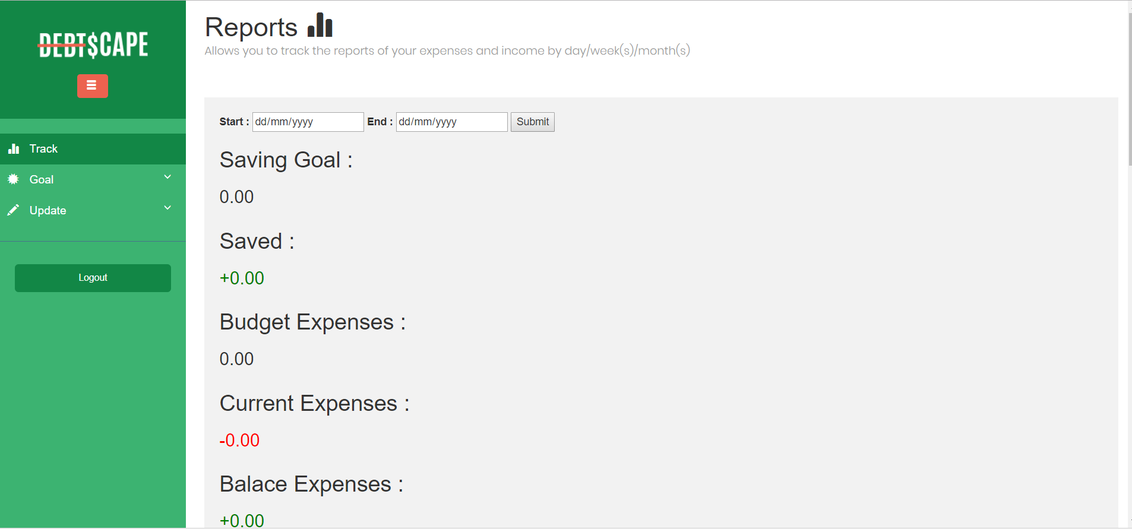

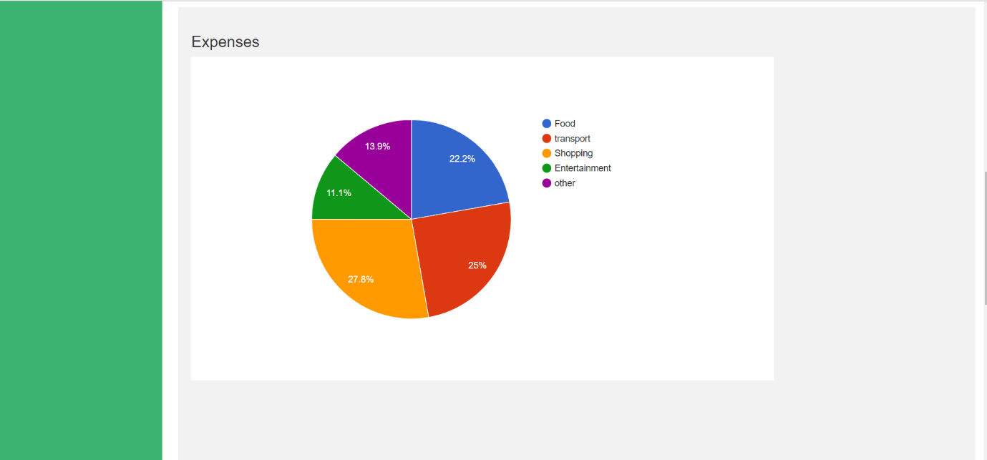

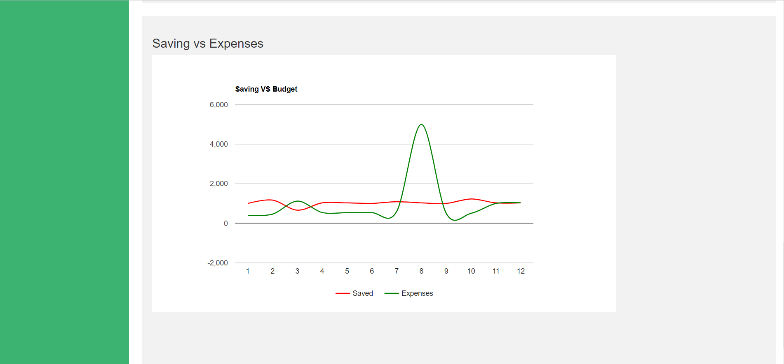

1. Goal page

This page is used to insert goal. User need to insert their name target saving and duration for their goal. This page also will show either user achieve their goal or not.

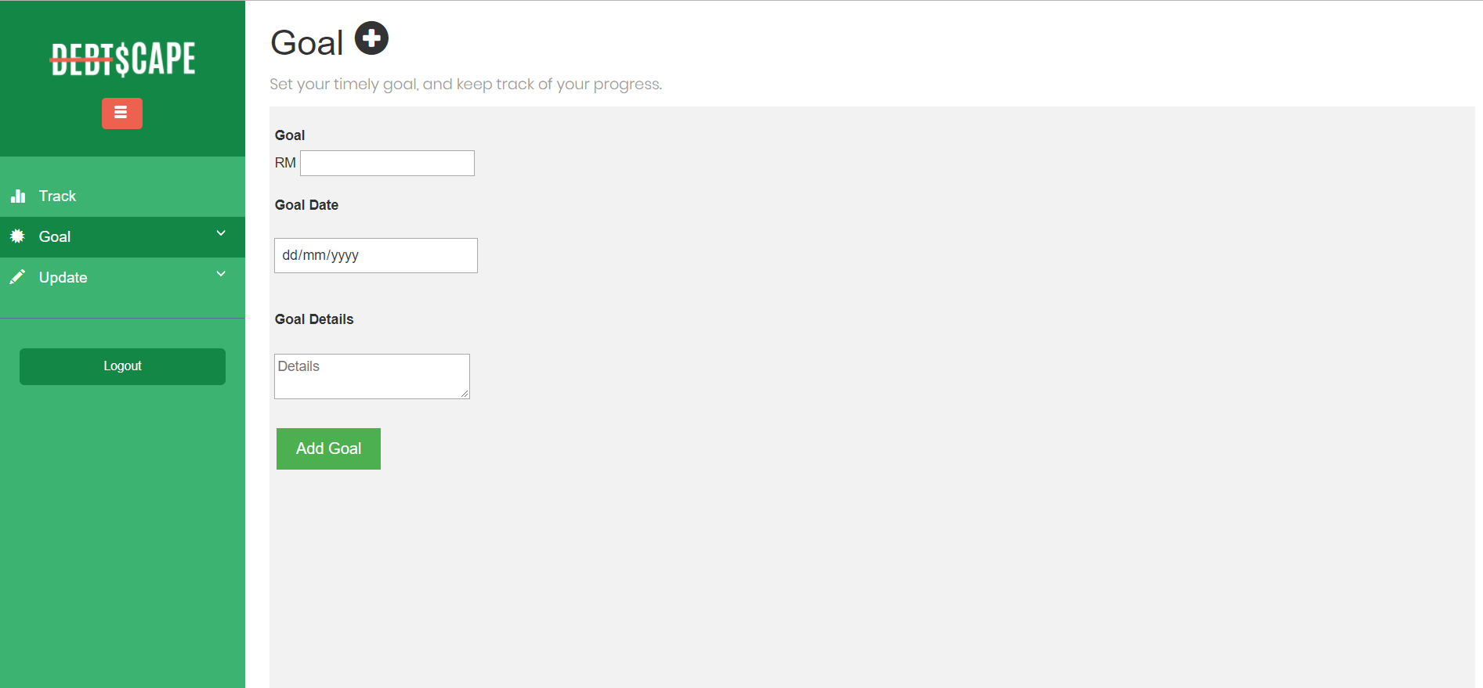

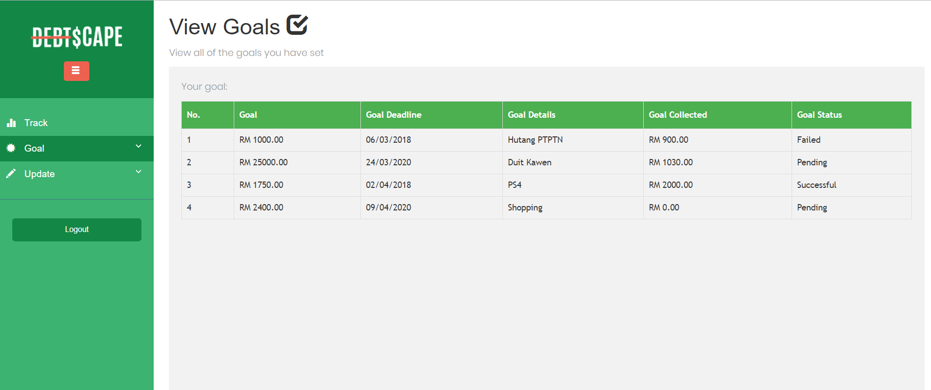

1. Expenses page

This page for user to insert their expenses for tracking. User need to insert category , amount and date. User also can view their daily expenses on this page.

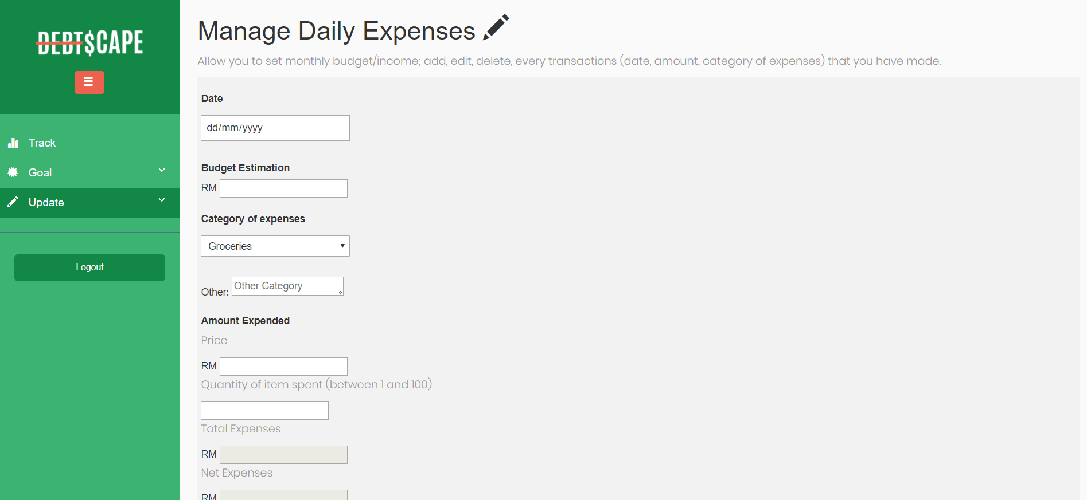

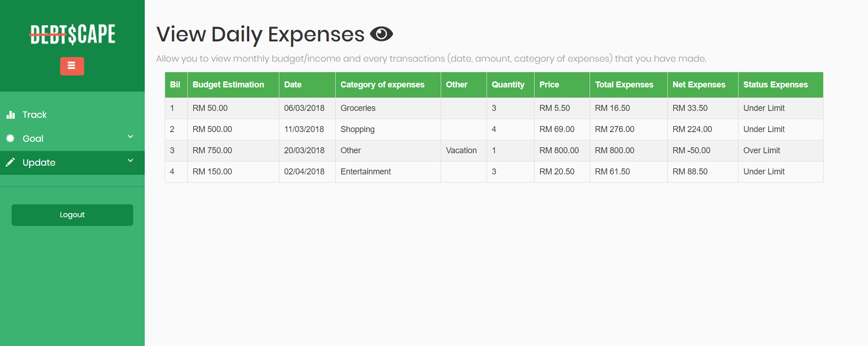

**Link to GitHub.com**